Homework # B : TinyDB Vs SQLite Initial Report

Ruchi Panwar(rpanwar@kent.edu)

Software Testing

Fall 2015

Professor: Dr. Gregory S DeLozier

Nov 5th , 2015

**Introduction**

TinyDB is a tiny, document oriented database. It is designed to be simple and fun to use by providing a simple and clean API. Its written in python and does not need any external severs such as PyMongo.

**Purpose**

The objective is to create a test plan to compare the TinyDB with SQLite and determine whether it's really easy to use as per the features and performance.

**Test Plan**

|  |  |  |  |  |
| --- | --- | --- | --- | --- |
| **TinyDB Vs SQLite - Test Plan** | | | | |
| **Sl. No** | **Test Description** | **Status - TinyDB** | **Status - SQLite** | **Comments** |
| 1 | Create a table and insert the data |  |  |  |
| 2 | Retrieve one record from the table. |  |  |  |
| 3 | Retrieve all the records from the table. |  |  |  |
| 4 | Retrieve one column from the table. |  |  |  |
| 5 | Retrieve all the columns from the table. |  |  |  |
| 6 | Delete one record from the table. |  |  |  |
| 7 | Delete all the records from the table. |  |  |  |
| 8 | Update one or multiple records into the table. |  |  |  |
| 9 | Check whether the values can be roll-backed in case of error. |  |  |  |
| 10 | Check whether the table has fixed structure or dynamic structure. |  |  |  |
| 11 | Check the performance of the database while inserting and retrieving the records. |  |  |  |

**Test Methodology**

The efficiency of TinyDB database will be measured based on performance, usability and overall satisfaction. To do so, a python program will be created to check various features and functionalities of TinyDB. The obtained test results will be compared with SQLite functionalities, to make sure that the TinyDB is fast and reliable.

In order to measure the performance, the execution time for a given query for TinyDB will be compared against the execution time of the SQLite query. Also the basic functions of TinyDB will be reviewed to check whether the necessary functions are available or not.

**Prototype**

Test case 11 from the table is used as a prototype. In this particular scenario, the program will check whether, the table has fixed structure or dynamic structure.

As you can see in the below screen shots in TinyDB, you don't need to define the structure of database and you can have different structures while inserting the records.

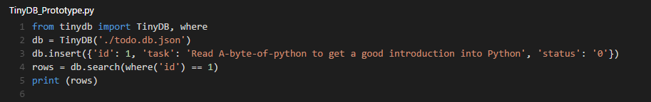

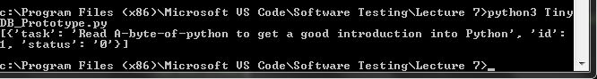

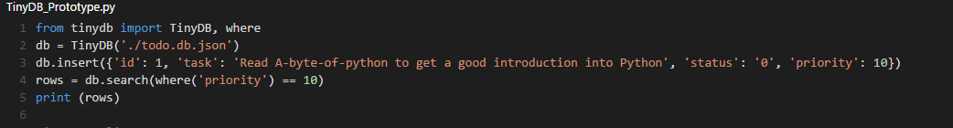

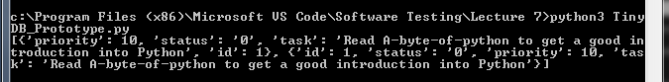

But in SQLite you need to have a fixed structure while creating the table and if you would like to have a different structure than the defined one, it will error out. In order to solve the error, you need to use the function - ALTER TABLE.

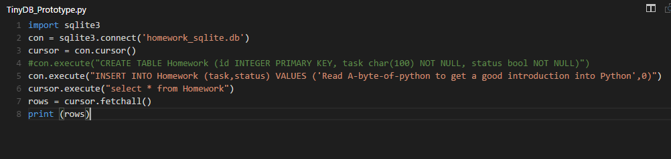

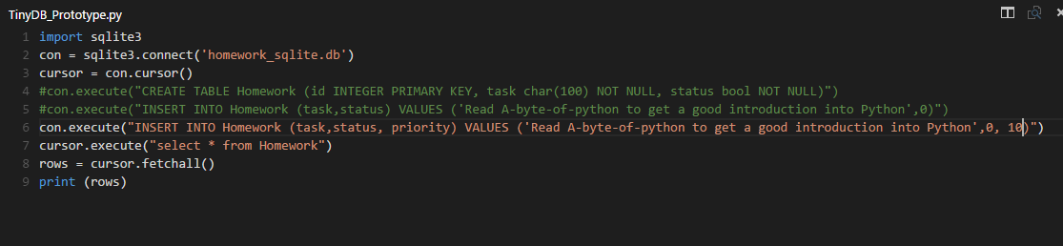

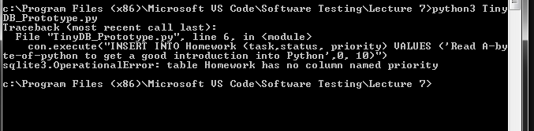

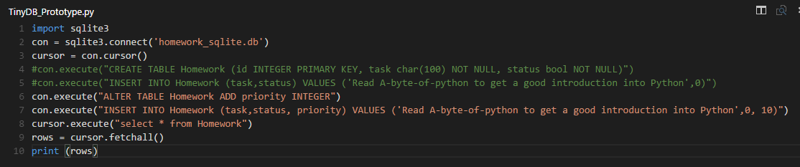

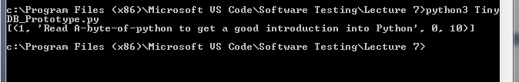

**Conclusion**: TinyDB is more dynamic in terms of structure and doesn't need any extra effort to do so,

unlike SQLite.

References

*https://* *www.google.com/\**

*http://tinydb.readthedocs.org/en/latest/intro.html*